**Practical File questions**

1. Write a C program to check whether a number is palindrome or not.
2. Write a C program to find sum of all even numbers between 1 to n.
3. Write a C program to count number of digits in a number.
4. Write a C program to check whether year is leap year or not using conditional operator.
5. Write a C program to find sum of digits of a number as follows:

If the number has even number of digits like: 1234=> (1+4) + (2+3)=10

If the number has even number of digits like: 12346 =>(1+6) + (2+4) + 3 =16

1. Write a C program to swap first and last digits of a number.
2. Write a C program to print all Prime numbers between 1 to n.
3. Write a C program to print Fibonacci series up to n terms.
4. Write a C program to find sum of series: $nx/1!+(n(n-1) x^2)/2!+…$ N terms.
5. Deepak wants to convert a character entered in lower case to uppercase and if it is entered in upper case then he would like to convert it to lowercase.
6. The Air Quality Index (AQI) shows the levels of health concerns for a particular area. The level of air quality for a given AQI is mentioned as below:

|  |  |
| --- | --- |
| AQI (Air Quality Index) | Level of Air Quality |
| >0 and <=50 | Healthy |
| >50 and <=100 | Moderate |
| >100 and <=200 | Unhealthy |
| >200 and <=300 | Very Unhealthy |
| >300 and <=500 | Hazardous |

1. Shyam resides in South Delhi. Draw a flow chart and write a program to help Shyam to find out what is the level of air quality in his area depending upon the AQI of the area.
2. Program to take the value from the user as input electricity unit charges and calculate total electricity bill according to the given condition: For the first 50 units Rs. 0.50/unit………….For the next 100 units Rs. 0.75/unit…..For the next 100 units Rs. 1.20/unit ……………For unit above 250 units Rs. 1.50/unit………An additional surcharge of 20% is added to the bill…….Using the switch statement.
3. Program to count the total number of notes in a given amount. Using the switch statement.
4. Print the following patterns:

1. 3.

1

1 2 3

1 2 3 4 5

1 2 3 4 5 6 7

*

* *

* * *

* * * *

2. 3.

A

B B B

C C C C C

D D D D D D D

E E E E E

F F F

G

1

1 2

1 2 3

1 2 3 4

1 2 3 4 5

4.

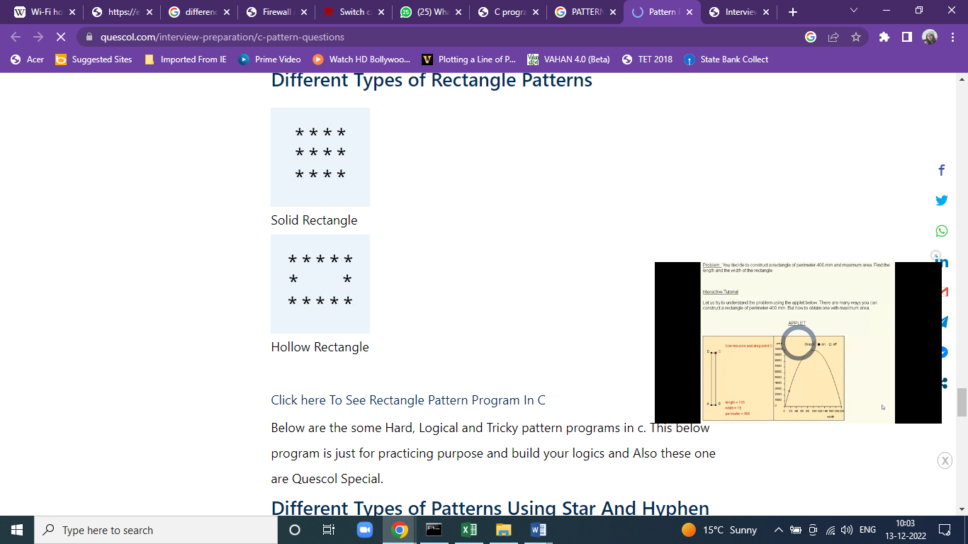

1. Write a program in C to Convert decimal to binary of a number by using bitwise operator.
2. Write a program in C to Turn OFF or ON a bit at a given position.
3. Write a program in C to check an integer is a power of 2?
4. Write a program in C to find the maximum and minimum element in an array.
5. Write a program in C to delete an element at desired position from an array.
6. Write a program in C to Find the Frequency of Characters in a String

**Note:**

* The code should be handwritten on the right-hand side with question on top while its printed output should be on left hand side.
* The first line of each output will be like :<Name> <Course><Section><Roll no>(Ex: Aman Sharma MCA A 13)
* Printed Front page with GEHU logo and index with page number for each question.
* **Draw flow chart diagrams for questions 1-11 and 15**.